|  |  |  |  |  |
| --- | --- | --- | --- | --- |
|  |  |  |  |  |
|  |  |  |  |  |
|  |  |  |  |  |

4.roč. **Zlomky a rozdeľovanie** Meno: _____________________

**1. Vymaľuj podľa zadania:**

jednu tretinu jednu šestinu jednu polovicu

|  |  |  |  |  |  |
| --- | --- | --- | --- | --- | --- |
|  |  |  |  |  |  |
|  |  |  |  |  |  |
|  |  |  |  |  |  |
|  |  |  |  |  |  |

**2. Aká časť je vyfarbená?**

_________________ _____________________ _______________

**3. Rozdeľ bonbóny 4 deťom. Koľko bonbónov dostane jedno dieťa?**

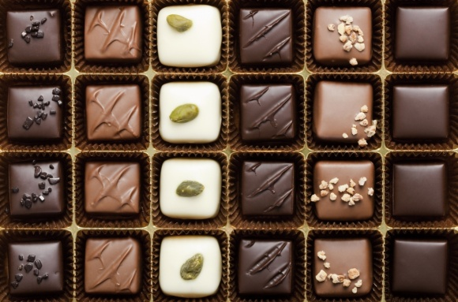

Odpoveď:

Výpočet:

**4. Vypočítaj.**

|  |  |  |  |  |
| --- | --- | --- | --- | --- |
| polovicu | tretinu | štvrtinu | pätinu | osminu |
| z 12 = | z 18 = | z 32 = | z 35 = | zo 64 = |
| z 200 = | zo 60 = | z 80 = | z 50 = | zo 16 = |